
NEIL W. TENNANT
tennant.9@osu.edu
If you email me, please use the header PHIL 655: YOURNAME.

Professor
Department of Philosophy

  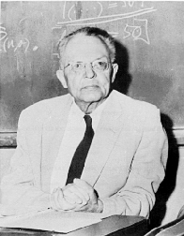  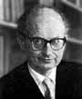 | Spring Term 2005  PHIL 655: Philosophy of Science  Lecture/Seminar  48 Derby Hall  9:30 - 11:18 a.m.  Aims of this course. We aim to become conversant with all the major concepts and controversies of mainstream discussion in the 'general' philosophy of science (as opposed to its more specialized areas, such as the philosophy of quantum physics).  Topics. We shall be covering topics drawn from the following list: The structure of scientific theories; theory-ladenness of observational evidence; the Quine-Duhem problem; commensurability of competing scientific theories; simplicity; rationality of scientific change; the criterion of cognitive significance; the nature of scientific paradigms; conceptual change in science.  Textbook: Ian Hacking, ed., Scientific Revolutions, Oxford Readings in Philosophy, 1981.  Additional Reading: Neil Tennant, The Taming of The True, Clarendon Press, Oxford, 1997 (pbk. edn. 2002); chapter 11, on cognitive significance. | 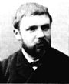  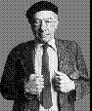  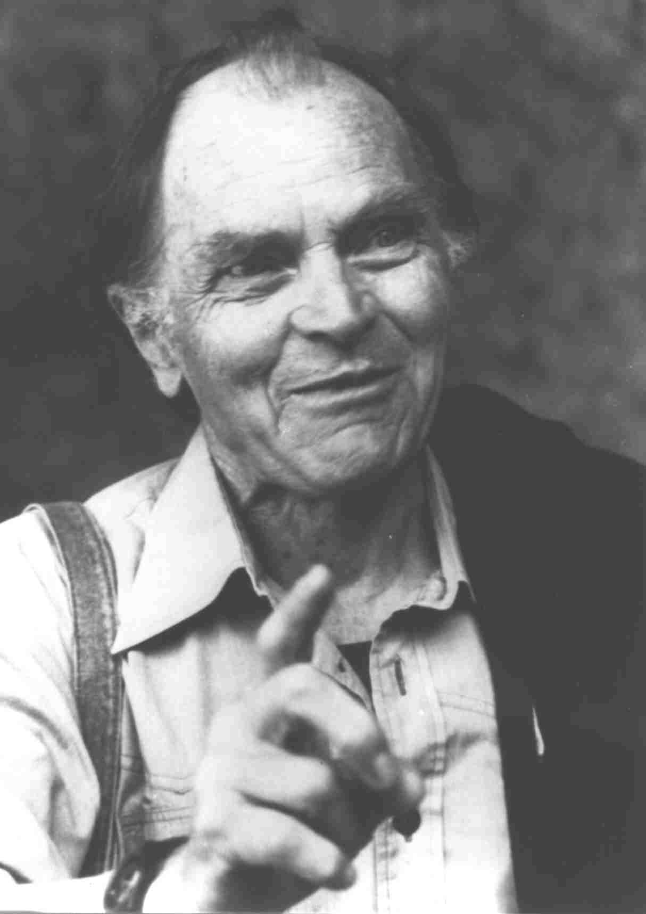
Background reading
(those in bold face are on Reserve in the Main Library):
- Thomas Kuhn, The Structure of Scientific Revolutions, University of Chicago Press, 1996.
- Paul Feyerabend, Against Method, Verso, New York, 1988.
- Richard Braithwaite, Scientific Explanation, Cambridge, 1953.
- Alexandre Koyré, From the Closed World to the Infinite Universe, Johns Hopkins Press, 1957.
- Herbert Butterfield, The Origins of Modern Science, Bell, London, 1949.
- Norbert Hanson, Patterns of Discovery, Cambridge University Press, 1958.
- Norman Campbell, Foundations of Science, Dover, New York, 1957.
- Karl Popper, The Logic of Scientific Discovery, Hutchinson, London, 1959.
- Pierre Duhem, The Aim and Structure of Physical Theory, Princeton University Press, 1954.
- Imre Lakatos and Alan Musgrave, eds., Criticism and the Growth of Knowledge, Cambridge University Press, 1970.
- Larry Laudan, Progress and its Problems, University of California Press, 1977.
- Barry Barnes, Scientific Knowledge and Sociological Theory, Routledge and Kegan Paul, London, 1974.
- Mary Hesse, The Structure of Scientific Inference, Macmillan, London, 1974.
- Clark Glymour, Theory and Evidence, Princeton University Press, 1979.
- Bas van Fraassen, The Scientific Image, Oxford University Press, 1980.
- Nancy Cartwright, How the Laws of Physics Lie, Oxford University Press, 1983.
- Ian Hacking, Representing and Intervening: introductory topics in the philosophy of natural science, Cambridge University Press, 1983.
- Wesley Salmon, Scientific explanation and the causal structure of the world, Princeton University Press, 1984.
- Elliott Sober, The nature of selection : evolutionary theory in philosophical focus, Cambridge, MIT Press, 1984.
- Arthur Fine, The shaky game : Einstein, realism, and the quantum theory, University of Chicago Press, 1986.
- Lawrence Sklar, Philosophy of Physics, Boulder:Westview Press, 1992.
- Michael Redhead, From Physics to Metaphysics, Cambridge University Press, 1995.
A useful on-line bibliography in philosophy of science
Assessment:
Item | Date due | Weight
Class presentation | Wednesday of the week in question | 20%
Term paper | Wednesday, June 1 | 80%
Class attendance and participation | Every session! | An adjustment factor
Policy on attendance at classes
Plagiarism
Advice on writing essays
Term paper due on tba; worth 80% of grade.
Write about 4000 words on one of the following topics. The material will be easy to find in the textbook.
1. @.
2. @.
3. @.

